03/28/2023
Vault Data Standard - Themes Support
Autodesk Vault 2023 Clients introduced an updated themed user interface. As a user, I can select the Light (default install), Dark, or the legacy Classic theme for Vault Explorer. The CAD addins, like Vault for AutoCAD or Inventor, adopt the parent application's theme, Dark or Light. 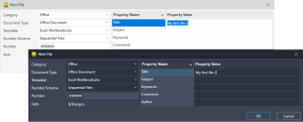
Vault Data Standard (VDS) fully supports themes starting with the 2023 Update 2 as a minimum release version. The default configuration of Update 2 renewed all dialogs and data sheets.
Now - there is the question, how can your customized VDS configuration benefit from these new capabilities? Unfortunately, this question is rarely asked :(. Instead, I see forum posts, support requests, and emails asking, "We updated to Vault Professional 2023, and now all Data Standard dialogs are broken!"
If your custom dialogs (migrated from earlier Vault releases) miss the title bar, pull-down menus, or even more, you must update the style section of your dialogs and data sheets. Acknowledged - this is unexpected work. But I can guarantee that you will like the result and the simplification if you have tried before to make your dialogs stylish.
I put together step-by-step instructions on updating your customized files: Autodesk Vault Data Standard 2023 - Updates and Migration. If you are familiar with VDS but less with "Themes" and "Styles," start reading the crash course first. Experienced configuration administrators will benefit from tips, deriving themed messaging, and more. 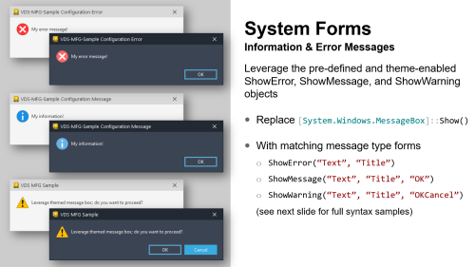
I hope you enjoy it!
- Markus

